**SQL_Reverse Engineering**

**Reverse-engineering** is the act of dismantling an object or process to see how it works. It is done primarily to analyze and gain knowledge about the way something works but often is used to duplicate or enhance the object.

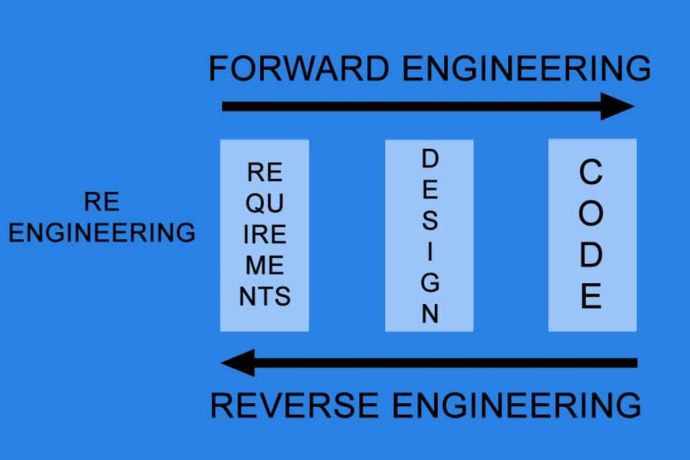

* **SQL Reverse Engineering:**

Database reverse engineering is the process that involves obtaining a database schema through its implementation, that is, through the definition of its objects.

**SQL Script**

**Model (ERD)**

1. **Let’s perform SQL reverse engineering by creating a SQL Script and converting it into an ERD model.**

|  |
| --- |
| Ward |
| Ward_No |
| Floor |
| Nurses |
| Beds |

Schema –

|  |
| --- |
| Patient |
| ID |
| Name |
| DOB |
| Address |
| Doctor_ID |
| visit_date |

|  |
| --- |
| Doctor |
| Doctor_ID |
| Doctor_name |
| Specialization |
| Ward_No |
| Salary |

